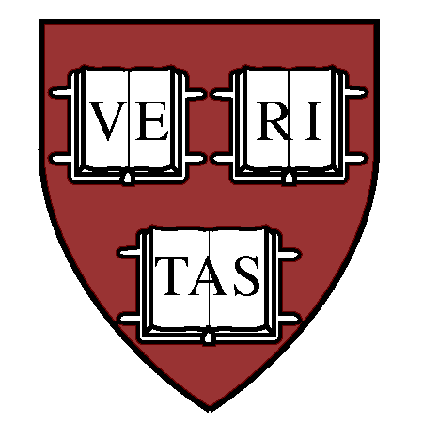 | The Tenth Harvard-Smithsonian  Conference  on Theoretical Astrophysics | 

Scientific Program
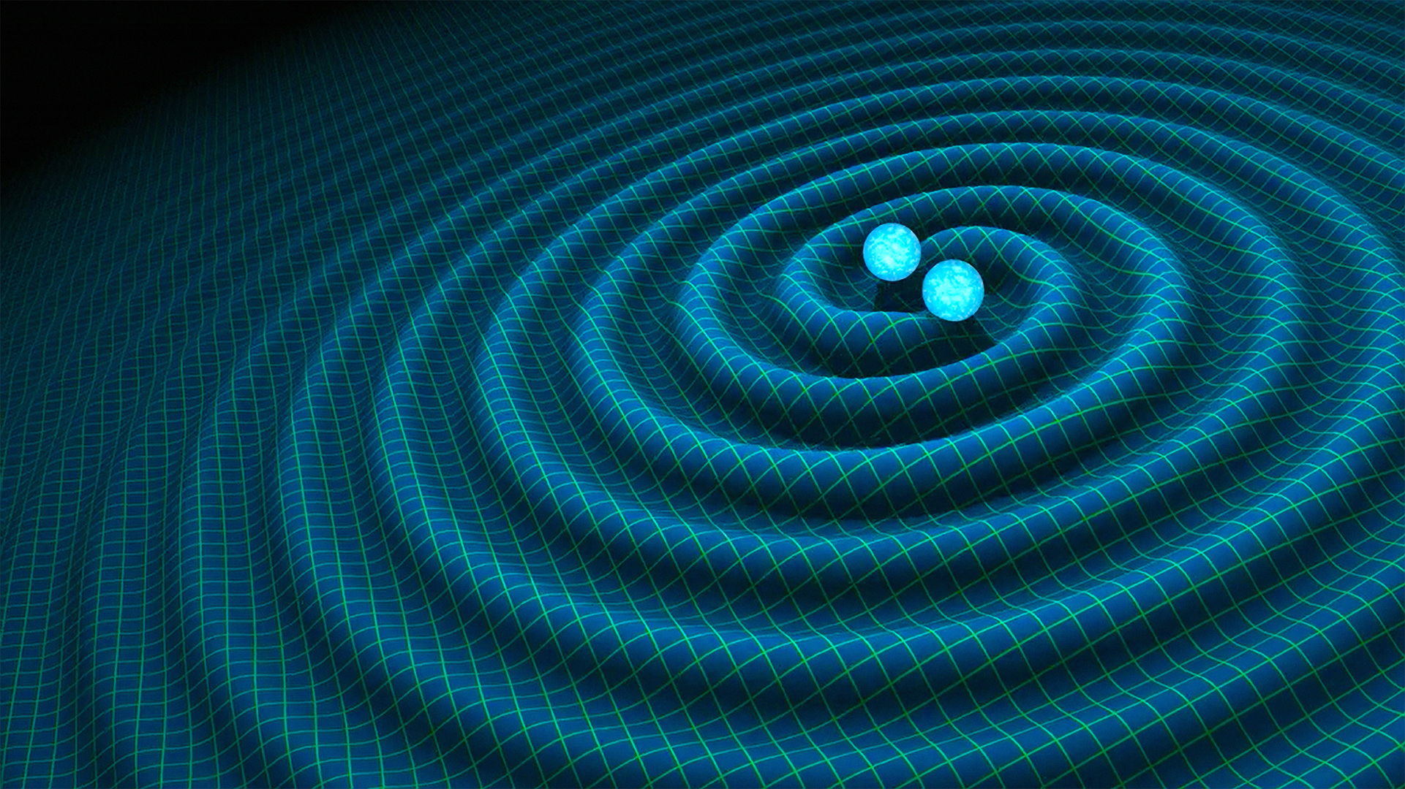

Credit: R. Hurt/Caltech-JPL

Gravitational Wave Astrophysics

Sponsored by Raymond and Beverly Sackler and Irwin Shapiro

Monday, May 7th through Wednesday, May 9th, 2018
Sheraton Commander Hotel, 16 Garden Street, Cambridge, MA
Hosted by the Institute for Theory and Computation, Harvard University
http://www.cfa.harvard.edu/events/2018/sackler/

All talks are 30 minutes (25+5)
Sessions held in the George Washington Ballroom; Coffee Breaks held in the adjacent Terrace Room

Monday, 9:00AM-5:30PM
9:00-9:05AM
Charles Alcock and Avi Loeb: Welcome

Session 1: Detectors and Techniques

Session Chair: TBD
9:05-10:30AM
Lisa Barsotti: Current status of LIGO / Virgo
Matt Evans: Future ground-based detectors
Karsten Danzmann: LISA

10:30-11:00AM Coffee Break

11:00-12:30PM
Maura McLaughlin: PTA

Session 2: Data analysis + parameter estimation + Model Selection

Alessandra Buonanno: Numerical / analytical relativity
Duncan Brown: Template-based search techniques

12:30-2:00PM Lunch Break

Session Chair: TBD
2:00-3:30PM
Laura Cadonati: Burst search techniques
MariaAlessandra Papa: Continuous source search techniques
Neil Cornish: Parameter estimation (methods review)
3:30-4:00PM Coffee Break

4:00-5:30PM
Will Farr: Model Selection

Session 3: Source populations

Ilya Mandel: Black hole binary formation – field (common envelope)
Selma de Mink: Black hole binary formation – field (non-common envelope)

Tuesday, 9:00AM-5:30PM
Session 3: Source populations, cont’d

Session Chair:TBD
9:00-10:30AM
Fred Rasio: Black hole binary formation – dynamical
Smadar Naoz: Black hole binary formation – galactic nuclei
Deirdre Shoemaker: Black hole binary - simulations

10:30-11:00AM Coffee Break

11:00AM-12:30PM
Dan Holz: Neutron star binary - source population
Stephan Rosswog: Neutron star binary - simulations
Monica Colpi: SMBH binaries

12:30-2:00PM Lunch Break

Session Chair:TBD
2:00-3:30PM
Stan Woosley: Outcomes of core-collapse supernovae
Adam Burrows: GW from core-collapse supernovae
Marta Volonteri: Cosmic Evolution of Black Hole Mergers and the Stochastic Gravitational
Wave Background

Session 4: Results from O2/O2

3:30-4:00PM Coffee Break

4:00-5:30PM
Ben Farr: BBH detections in O1/O2
Bangalore Sathyaprakash: Tests of GR
Paolo Pani: Alternative theories of gravity

Wednesday, 9:00AM-12:30PM
Session 5: Electromagnetic counterparts + follow-up

Session Chair: Edo Berger
9:00-11:00 AM
Wen-fai Fong: Short GRBs
Brian Metzger: Kilonova models
Raffaella Margutti: Radio/X-ray counterparts
Bence Kocsis: EM counterparts for LISA sources

11:00-11:30AM Coffee Break

11:30-12:30PM

Panel on EM follow-up
Marcelle Soares-Santos, Mansi Kasliwal, Stephen Smartt, Philip Cowperthwaite, Lindy Blackburn

12:30PM End of Conference

Wednesday, 6:30-10:00PM
(6:30PM)
Reception

(7:00PM)
Banquet Dinner in the Mount Vernon Ballroom

(8:30PM)
After-Dinner Talk by Rai Weiss with introductory remarks by Avi Loeb

